LINUX COMMANDS

- Whoami
- Used to display the current logged-in user. This helps to confirm which user account is active in the system.
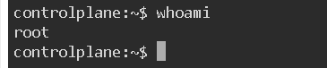
- Ls
- Lists all files and directories present in the current directory. It was frequently used to verify file or folder creation, deletion, and movement.

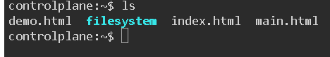

- touch
- Used to create new empty files. Multiple files can be created at once by providing several file names in a single command.

Vi

A command-line text editor used to create or edit files. To save and exit the editor, ESC :wq is used.

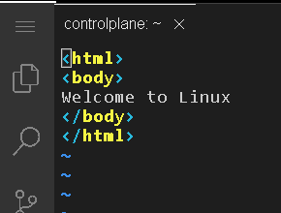

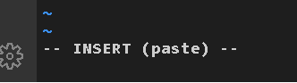

- Nano
- Another terminal-based text editor. It is simpler than vi. To save and exit, Ctrl + X, then Y, then Enter is used.
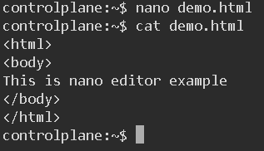

cat
- Displays the content of a file on the terminal. It was mainly used to verify the data written inside files.


7. mv
- Used to rename files or move files and directories from one location to another. This command was also used to move files between folders.

- Change one file name into another filename.

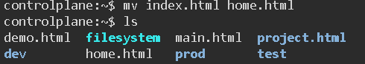

- Move files between folders.
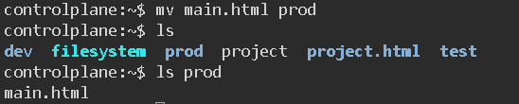

8. mkdir
- Creates new directories. Multiple directories can be created in a single command.

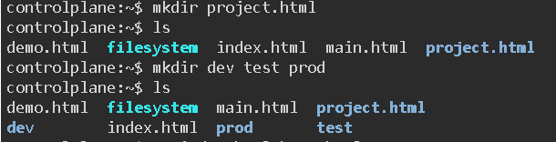

9. cd
- Changes the current working directory. It was used to move inside directories, come out of directories, and navigate across the folder structure.

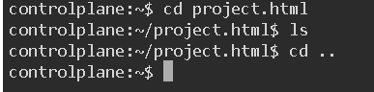
10. pwd
- Displays the absolute path of the current directory. This helps in understanding the exact location in the file system.

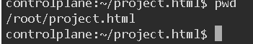

11. rm
- Deletes files permanently. It was used to remove unwanted files created during practice.
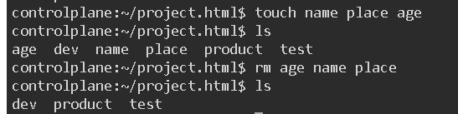
12. rmdir
- Deletes directories only if they are empty. It fails when the directory contains files.

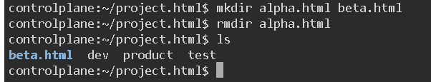
13.rm -rf
- Deletes directories forcefully along with their contents. This command was used when normal deletion was not possible.

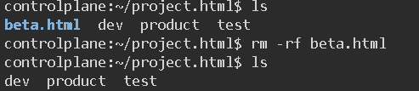

14. cp
- Copies files from one location to another. The original file remains unchanged.

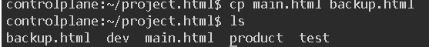

15. wget
- Downloads files from the internet using a URL. It was used to download an Apache Tomcat installer.

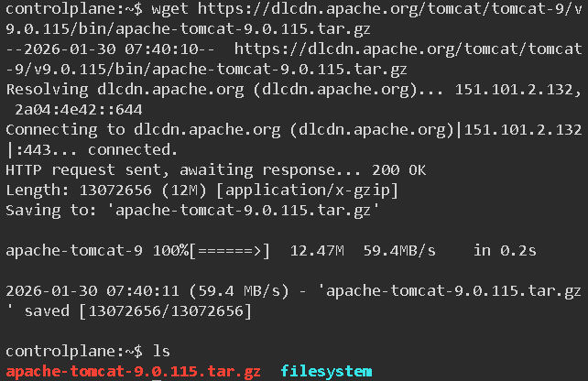

16. ping
- Checks network connectivity between the local system and another server or website.
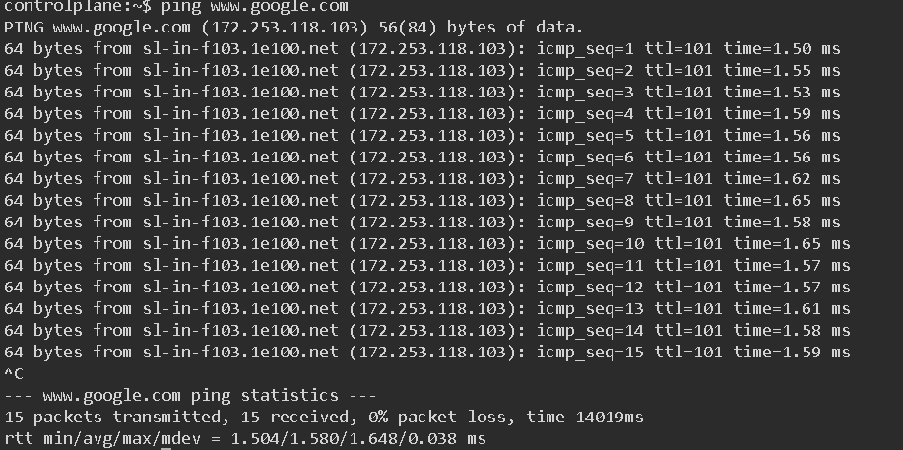

17. history
- Displays a list of all previously executed commands. Useful for tracking practice steps and revising commands.
